Prithee Prhap{ Instead

T H E M A N U A L L

(& Accompt{)

of a
H O U S E K E E P I N G

By a Curiu{ & Half-Long SPYRIT, now coming Familiar; who Afrighttd Much
from a SMAL FISURE in a Kitchin Wal on The Hottest Day Of Awgust,
When None Witnesd Him

in the Yeer of Our Lord
1759
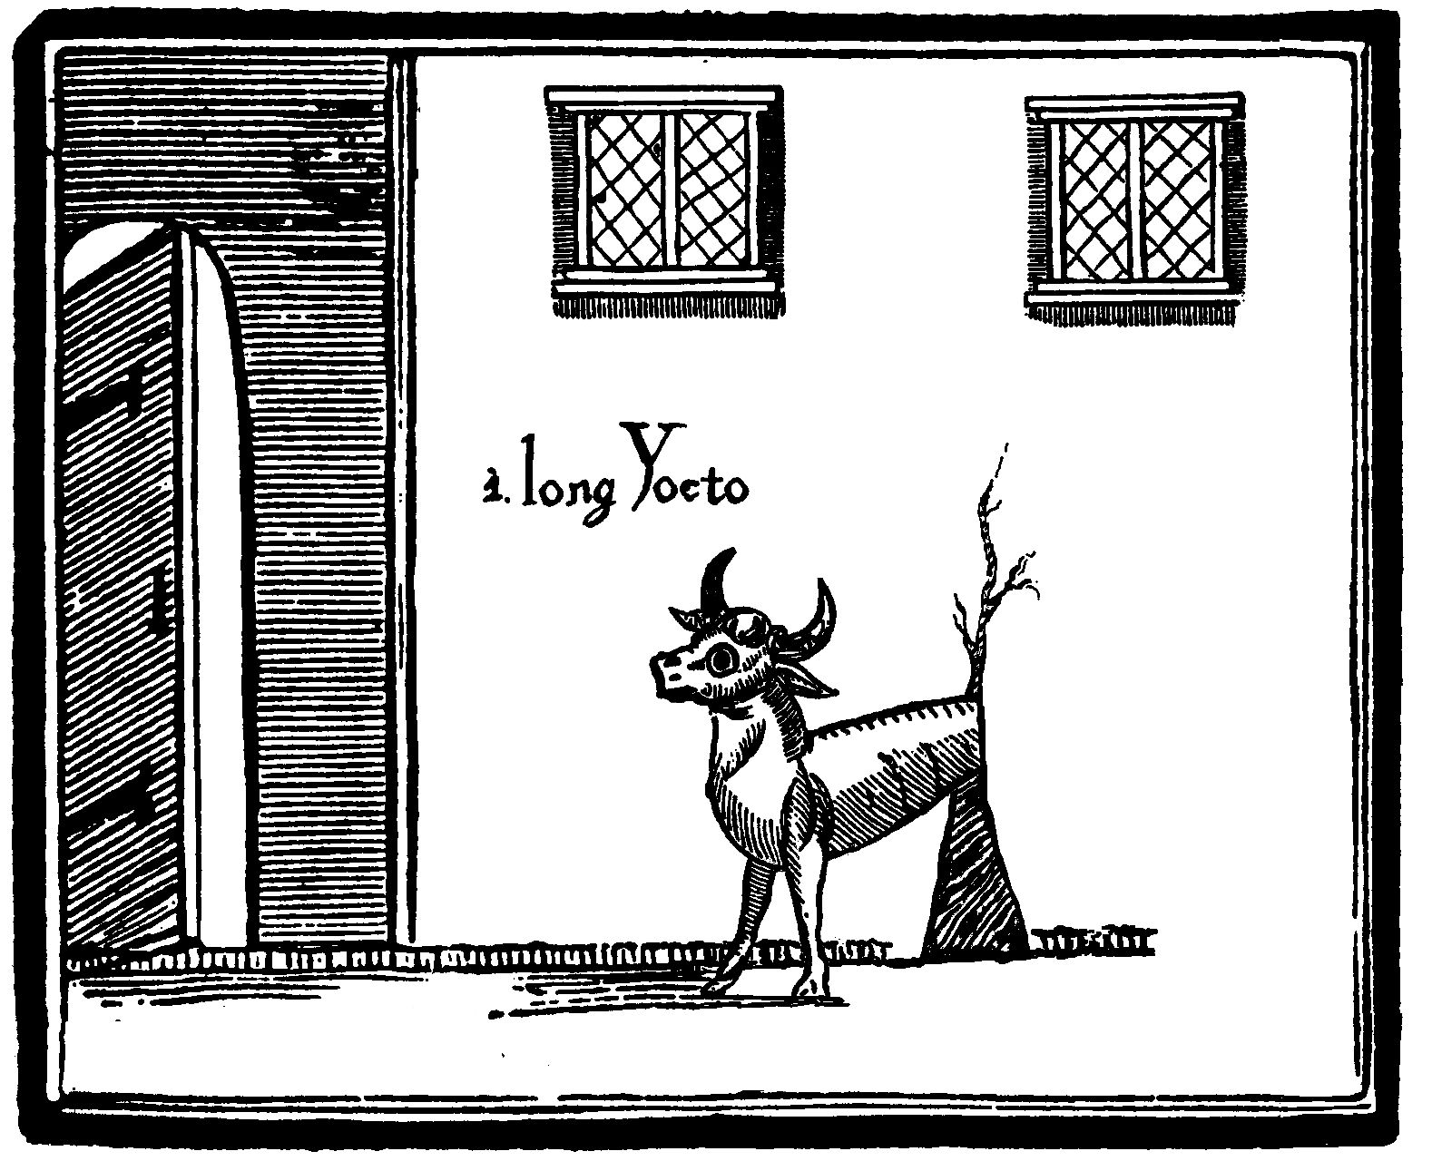

Being Now Witnefd and Reveald for Thy Fancy or Aplication by Myself;
one ANNE LATCH; Being an Honest Wiman Past Shuttle{{ and Forth Daughter of

M R . C A L E B M A S O N

(The Mason)

Both ere of the Hamlet of Nighthead
on the Old Road to Nighcester & Sheffield & Part{ Other,
in the county{ of York{. & Derby{.

Included in thi{ Rare Pri{e Inherint; The Deed{ & Rite{ to that House
& That Kitchin in Which the SPYRIT made Shelter;

And wherein i{ Dictated how that House might {till be kept since my Departur; and Shewing Plain & Glamurle{{ Instruction on The Treatmint or Consistent Appliance of It{ Resident & Gleaming Servant, a Beast not of Hell nor any part beside{ it

Through good Husbandry or Wifry, {oft Tuche{ and speaking{ of Magic;
the Article{ of the Moon and Some Conceded Sheap{

In return for the chymick of Poultice{, Chrism{; the telling of new Time{, the Manufectur of Charm{, Geolocation{, Sibyl{, Decouzining, Cury Without Fire; a Botany within hi{ Realm; the Learning of One or More Secrit{ ({uch a{ the solution of Hi{ True Name{), Hi{ Origin{ & Sirage, Almanacking, and the Ea{ing of the Former Work of Astrologer{, Girdler{, Soilwarp{ and the Teller{ of Toad Doom{ hereabout{;

And {ome divertsome Tale{ & Exacting Record on Hi{ Provenance, Nature & Nurture,
Hi{ Yeer, Calendar{, Ufe{ and Ufele{{ne{{e{, Orison{, Mien{, Artefact{ & Contrivence{,
Apparant{, Rong{, Be{t Day{ and Worst Night{, Diet & Awful Power{


Printed and fold in thi{ present year; Mr William Whiflick;
by the sign of the Dolphin, Joiner Street, in the city of Sheffield

